09-02 Connect the Adafruit USB/TTL Serial Cable to Raspberry Pi

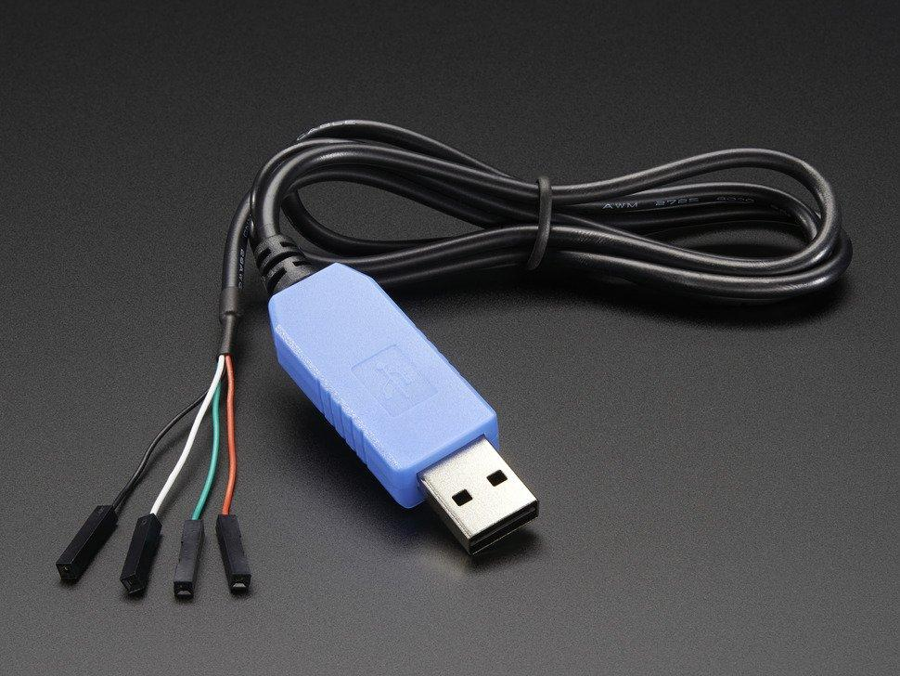

|  |  |
| --- | --- |
| **USB Cable** | **Raspberry Pi GPIO** |
| Red - 5vdc power | *Do not connect to both uart and another 5vdc source through the regular power connector*  But if you are careful, and need to do this for some reason…  Board pin 2 |
| Black - Ground | Board pin 6 - GND |
| White - RXD | Board pin 8 - TXD |
| Green - TXD | Board pin 10 - RXD |

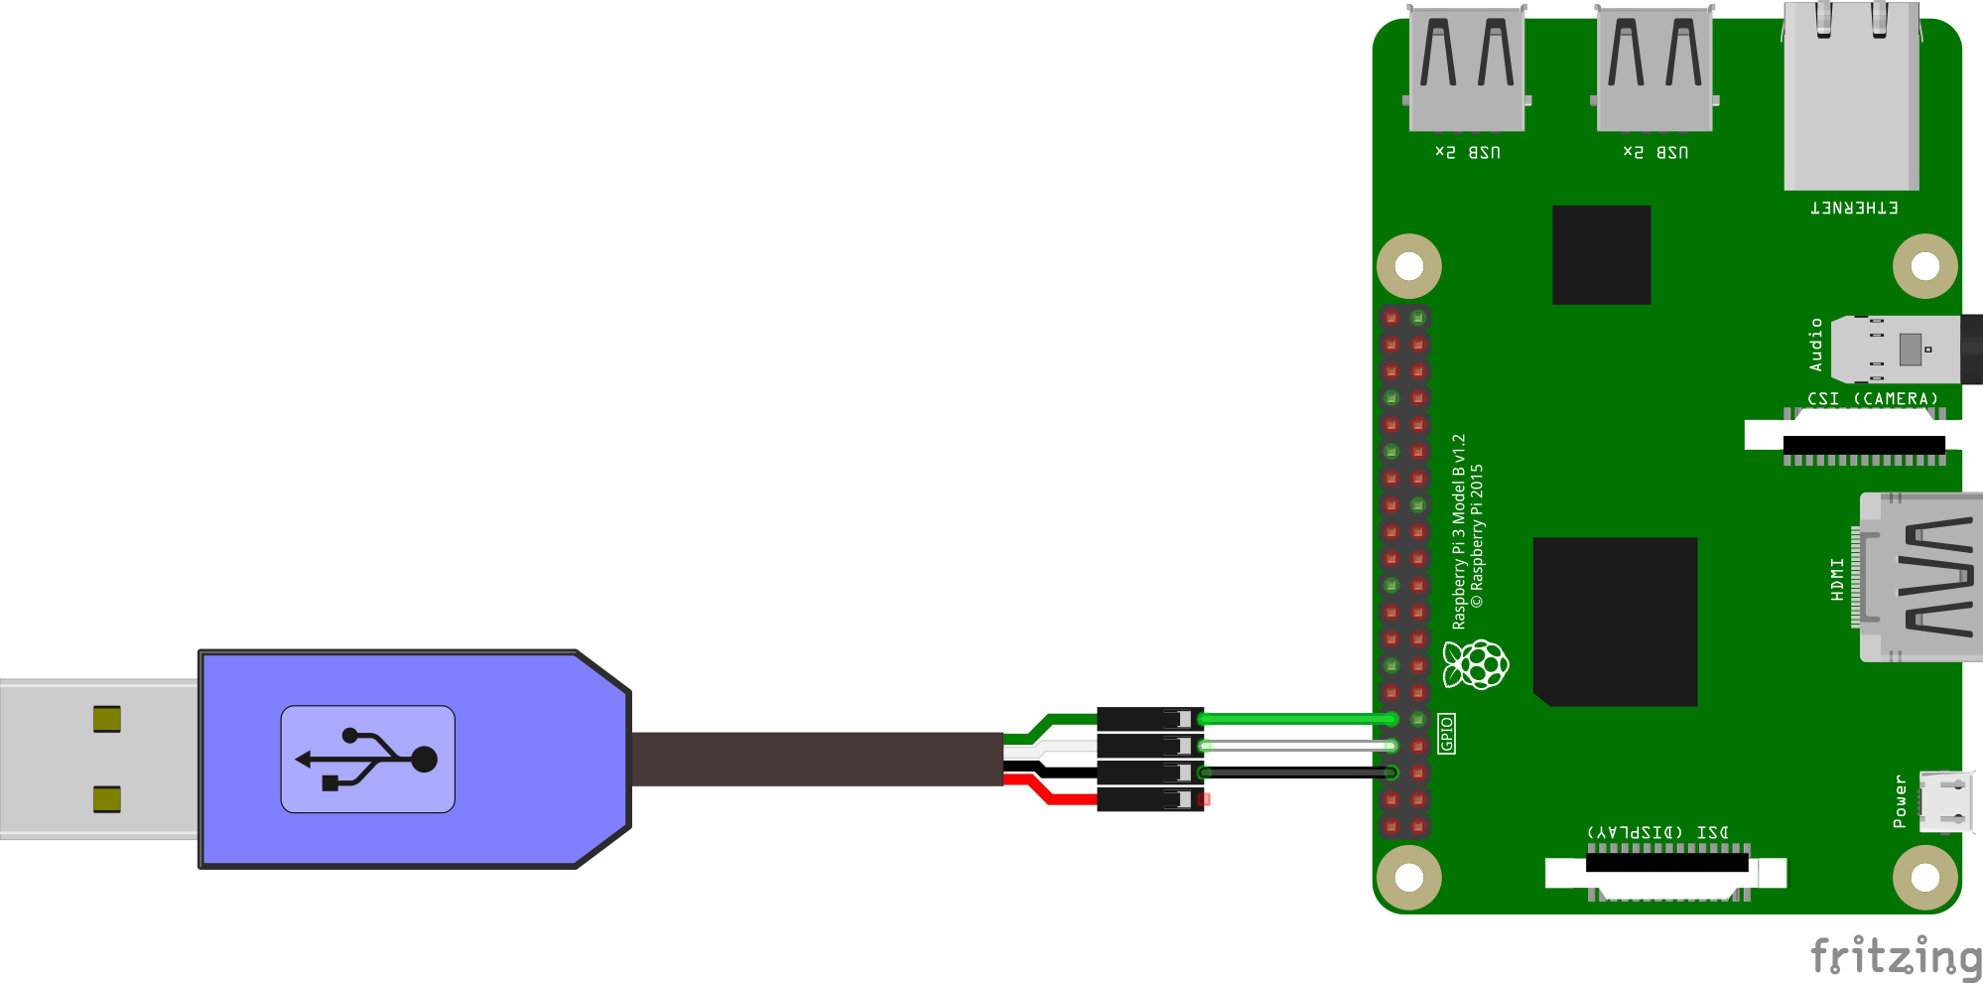

Notes:

* <https://www.adafruit.com/product/954>